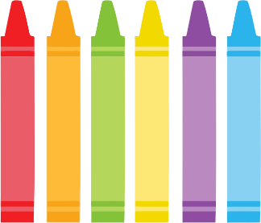

**Half Day/ Full Day Pre-Kindergarten Supply List**

**2025-2026**

**Summer sales are quickly approaching and they are the perfect opportunity to purchase Pre-K necessities for the start of the new school year. Many stores will begin to have sales for school supplies in August so we thought it would be most helpful for you to have a list ahead of time. The items that will be needed in our class include the following:**

* 2 boxes of tissues
* 2 containers of baby wipes (please refrain from Wet Ones brand-thank you!)
* 1 container of disinfectant wipes
* 1 roll of paper towels
* 6 jumbo glue sticks
* 2 boxes of 24 regular sized crayons
* 1 smock (labeled with your child’s name)
* 1 crib sheet (full-day students only; please refrain from sleeping bags-thank you!)
* 1 change of clothing in a Ziploc bag (labeled with your child’s name)
* 1 lunch bag (full-day students only)
* 1 regular sized backpack (please refrain from a roller backpack with wheels and note that Pre-K students will need full-sized backpacks so that the folders will fit inside)
* $7 for magazine subscription

*Please send in these items at your earliest convenience. Be sure to label everything with your child’s name, including each article of clothing. Thank you for your cooperation and support! I hope you have a wonderful summer and I look forward to seeing you in September.